**Mayfield School**

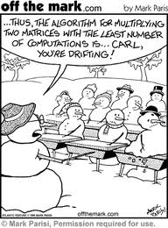

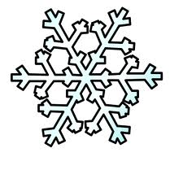

**Mathematics**

**Snow Day**

If you are reading this then it is obvious you have also received the very sad news about school today.

Sadly due to adverse weather beyond our control school will need to be shut today. I understand how difficult it will be without your math’s lesson today.

The mathematics department are just as upset as you are we can assure you.

To help you get through the day we have provided s selection of mathematical tasks to keep our young mathematicians thinking.

Enjoy the snow!

**Choose your Year Group and you will be directed to an appropriate mathematical snow themed task.**



**KS3 Snow Day Tasks**

Below you will first find a selection of online math’s games to help you develop your mental math’s methods.

We have chosen them all specifically with a snow theme. There are plenty of math’s games to be found on the Mymaths website and

BBC Bitesize which are great too and you are welcome to use these.

Online snow themed math’s games for all KS3 pupils

[Build a snowman](http://www.harcourtschool.com/activity/operation_snowman/) – Choose the correct operation to build your snowman successfully

[Penguin Placer](http://www.bbc.co.uk/schools/starship/maths/games/place_the_penguin/small_sound/standard.shtml) – You will need to know about place value to solve these penguin puzzlers

[Penguin Jump](http://www.mathgametime.com/games/penguin-jump-multiplication-game) – Get lots of practice for your times tables

[Snowball fight](http://www.personal-math-online-help.com/snowball-fight-multiplication-math-games.html%20\%20GAME1) – much warner than the real thing and you will get lots of practice for your times tables

[Ice Ice Maybe](http://www.mangahigh.com/en_gb/games/iceicemaybe) – this games all about the number skills again lots and lots of practice

You will also need to develop you functional skills in mathematics and the 3 tasks listed below all provide a great opportunity for you to achieve that.

Decide what type of learner you are most like and have a go at the task listed below that type of learner.

If you are feeling up for a challenge why not have a go at a task outside of your comfort zone? You never know you could surprise yourself.



For more information about the type of learner you are look at this website.

[Learning Styles](http://www.brainboxx.co.uk/a3_aspects/pages/vak_quest.htm)



**Kinesthetic tasks**

**Snowflakes**

Every snowflake has an infinite beauty which is enhanced by the fact that you never find another exactly like it. Nature combines her greatest skill and artistry in the production of snowflakes and generously fashions the most beautiful specimens on a very thin plane.

Why do snow crystals form in such intricate, symmetrical shapes?

Where is the creative genius that produces these miniature masterpieces of frozen water, quite literally out of thin air?

Snowflakes are created from polygons.

To create your own symmetrical snowflake designs follow the instructions on this worksheet.

[Create a snowflake](http://lionsden.tec.selu.edu/~smathis/645/snowflakes.htm)

You need to make different snowflakes from different polygons and identify all the lines of symmetry on your design.

Create a display of different snowflakes made from different polygons (squares, pentagons, hexagons, octagons) with different symmetry. Label all the lines of symmetry and name of polygon on your snowflake.





**Auditory tasks**

**Snow Word Graphs**

When the big freeze hits Britain then everyone is an expert and you are sure to hear some surprisingly repetitive news broadcasts.

You are going to investigate a few of the key snow related buzz words in the news.

All you need to do is listen to a news broadcast on the radio, on TV or online for 5 minutes. Keep a tally chart like the one below of how often each of the 10 snow related words are repeated.

Produce a series of graphs and charts to display your findings, either by hand or using a computer program to draw them.



You can choose from bar chart, pictogram, pie chart, line graph.



If you need some help on different types of graphs you can have a look on the [My Maths](http://www.mymaths.co.uk) website.



The login details are Login: mayfield Password: primenumber

Use the search to find the lesson you require.

Graphs and Charts explained.

|  |  |  |
| --- | --- | --- |
| **Word** | **Tally** | **Frequency** |
| snow |  |  |
| grit |  |  |
| winter |  |  |
| sleet |  |  |
| havoc |  |  |
| sledging |  |  |
| freeze |  |  |
| snowman/snowmen |  |  |
| snowball |  |  |
| emergency |  |  |



**Visual tasks**

**Geometry captured in snow**

This task is all about is about bringing mathematics to life with photographs. The snow falling can create some beautiful images.

Your task is to look for any kind of mathematics in what you see around you. Take photos and then create a PowerPoint or leaflet showing your Snow Day photos and all the mathematics they display.

All the photos you take will need a few sentences explaining the maths that can be seen

You can be looking for examples of symmetry, geometrical shapes, reflections, tessellations and lots more.

Below are a few examples to help get you thinking. Try to be a creative as possible.

*Parallel lines*



*Pythagoras Theorem!*

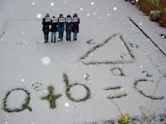

*Tessellating Shapes*

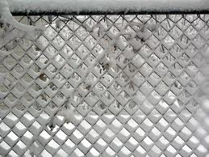



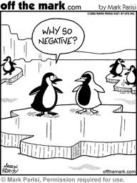

**KS4**

**Snow Day Tasks**

**Year 9 and 10**

You are a very lucky year group. You have been granted the gift of time today.

I hope you will choose to use your time wisely.

The best use for your time now is to do some revision.

Login to [My Maths](http://www.mymaths.co.uk)

The login details are Login: mayfield Password: primenumber

Then click onto booster packs

Choose the booster pack aimed at your target grade.

NEW! GCSE booster 3 and 4

NEW! GCSE booster 4 and 5

NEW! GCSE booster 6 and 7



 You will need to select a topic to revise (make sure it is something you need to practice) and then work your way through all the tasks until you feel confident in that area.

**Year 11**

You are a very lucky year group. You are so close to your final math’s GCSE exam now and you have been granted the gift of time today.

I hope you will choose to use your time wisely.

The best use for your time now is to continue with your revision.

Login to [My Maths](http://www.mymaths.co.uk)

The login details are Login: mayfield Password: primenumber

Then click onto booster packs

Choose the booster pack aimed at your target grade.

NEW! GCSE booster 3 and 4

NEW! GCSE booster 4 and 5

NEW! GCSE booster 6 and 7

NEW! GCSE booster 8 and 9



You will need to select a topic to revise (make sure it is something you need to practice) and then work your way through all the tasks until you feel confident in that area.